AI Assisted Coding
Name: KONDA SRIHARI
Roll no:2503A51289

Assignment no:16

Task 1 – Employee Management Database
Task : Create relational tables with keys/constraints and write the required JOIN, aggregate, and analysis queries.

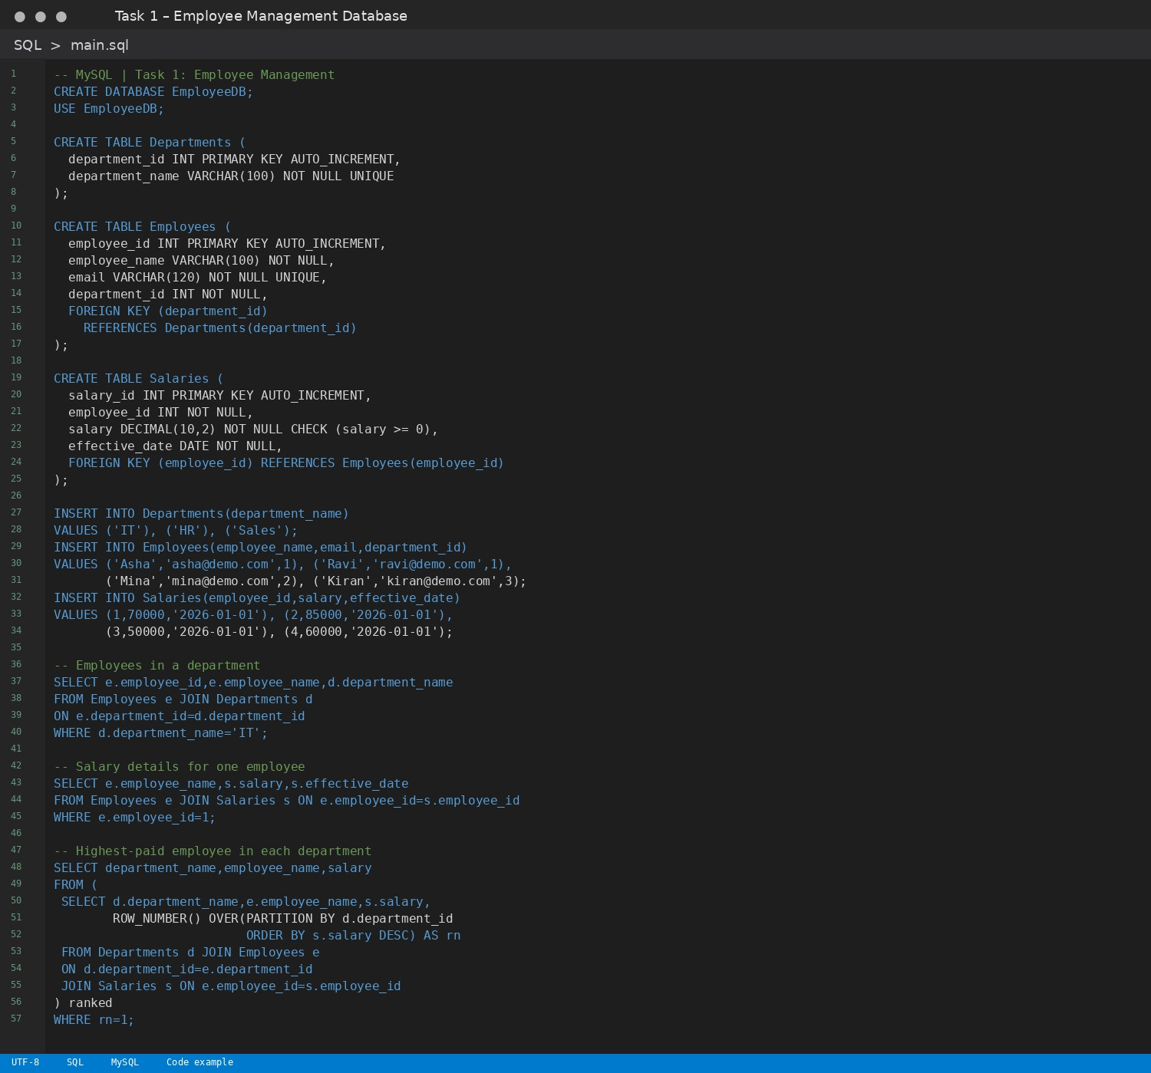
SQL Code

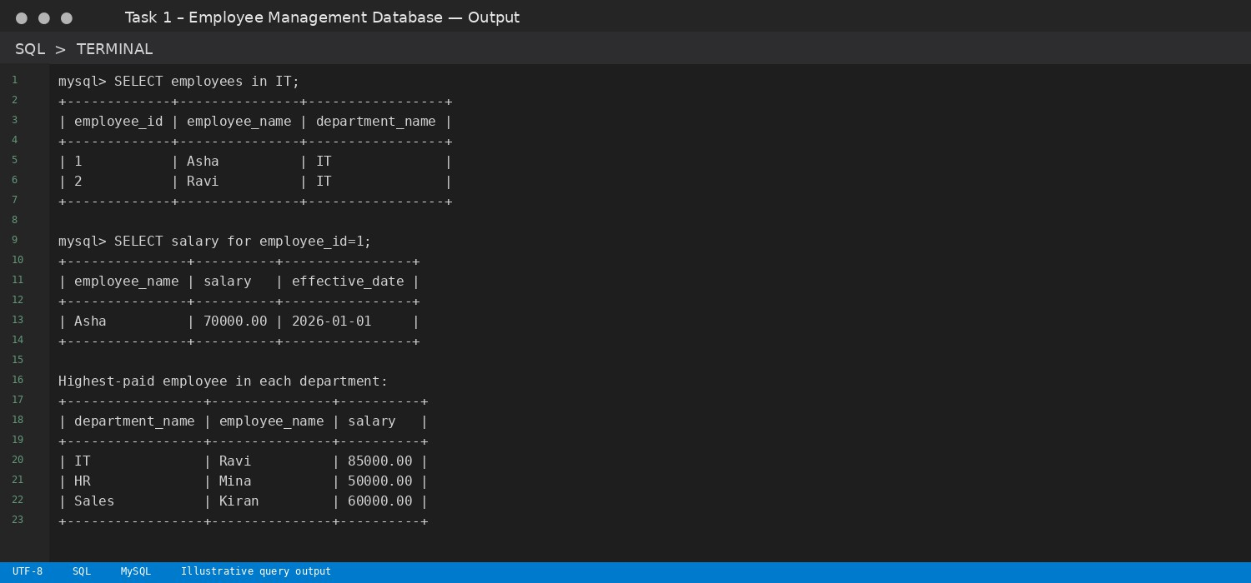
Note: For the airline task, available seats are calculated from booked tickets. For the hotel task, room availability uses overlapping date ranges, and occupancy is calculated for the selected date.

Task : Create relational tables with keys/constraints and write the required JOIN, aggregate, and analysis queries.

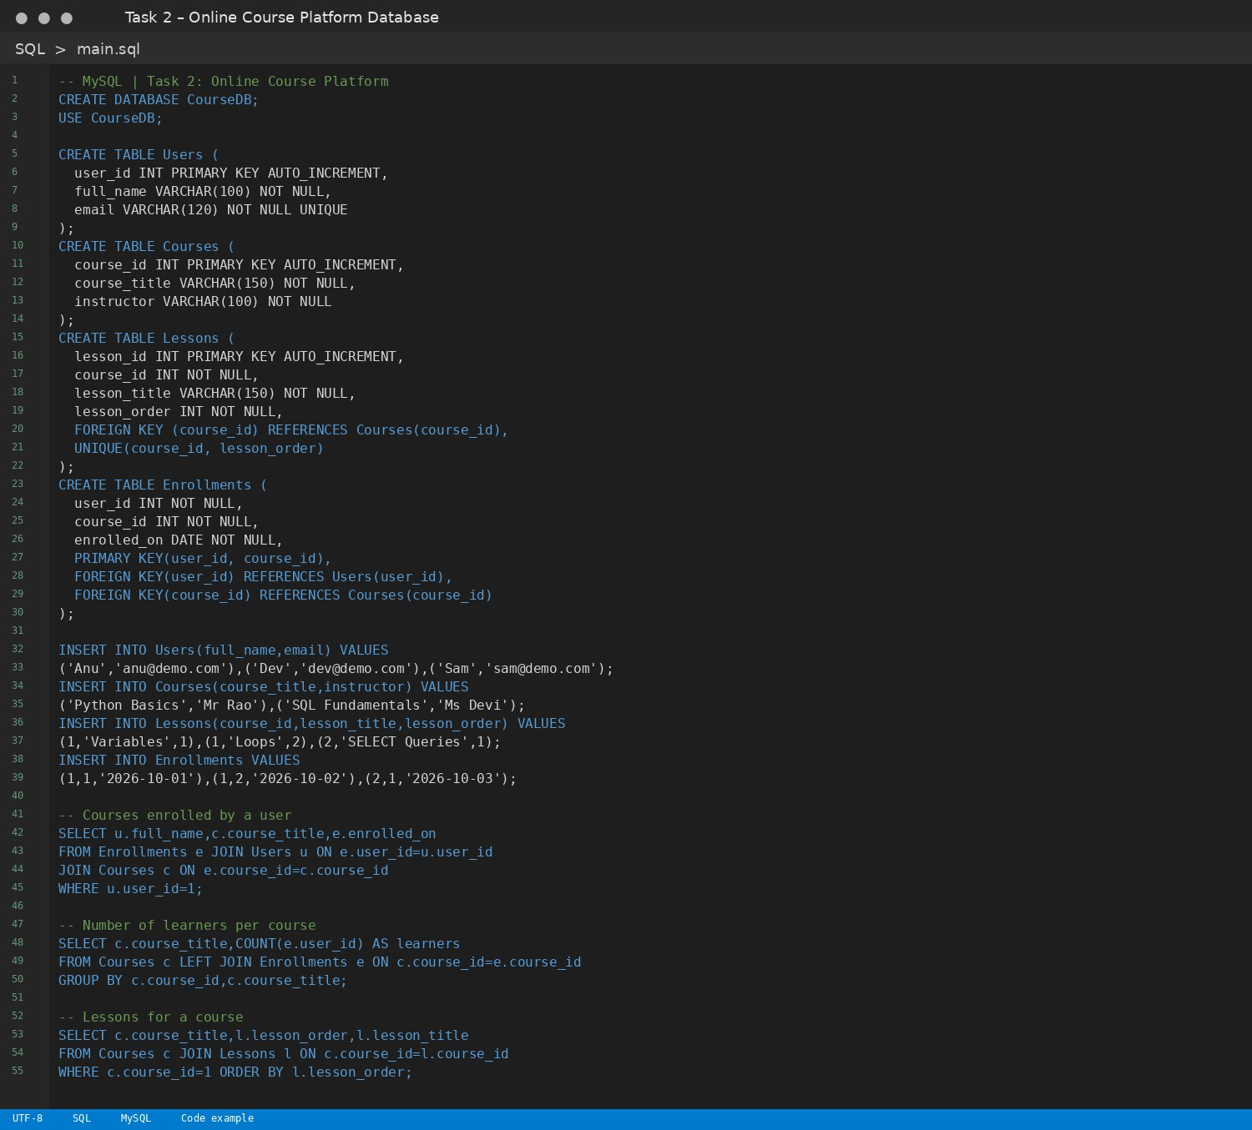
SQL Code

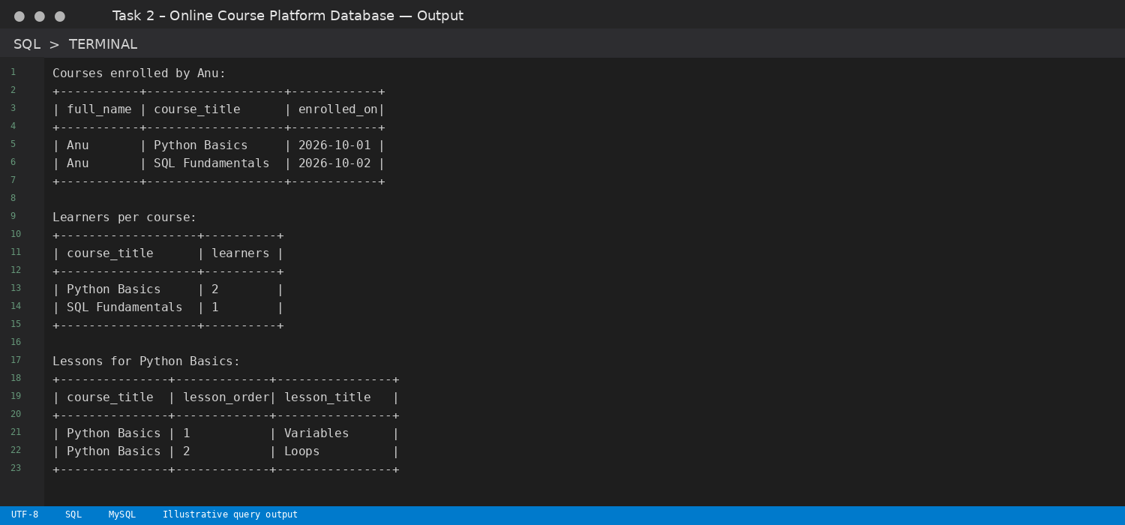
Note: For the airline task, available seats are calculated from booked tickets. For the hotel task, room availability uses overlapping date ranges, and occupancy is calculated for the selected date.

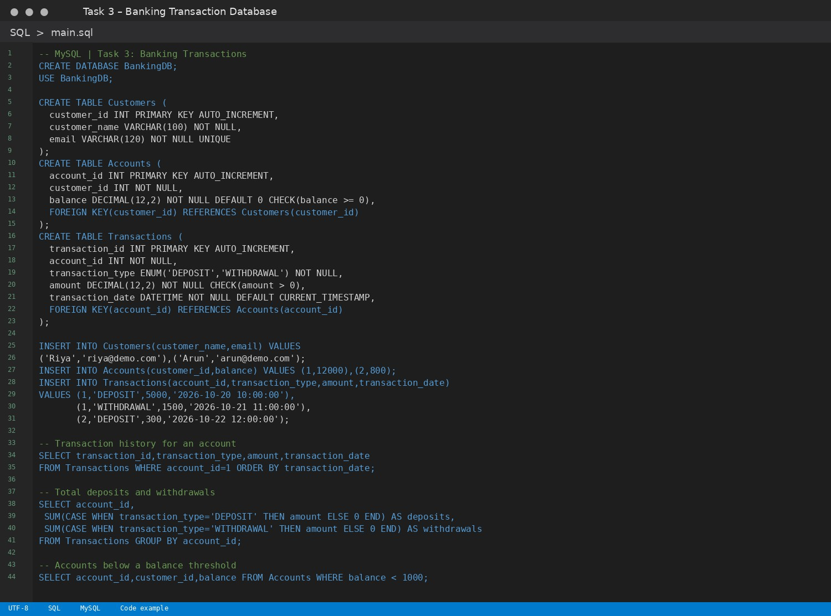

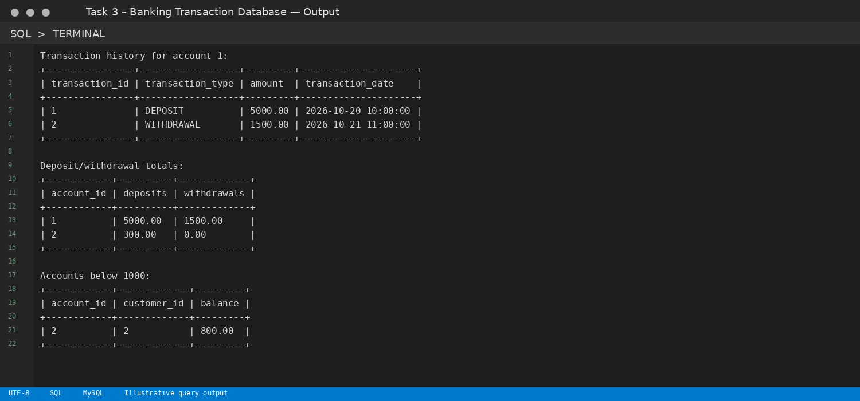
Note: For the airline task, available seats are calculated from booked tickets. For the hotel task, room availability uses overlapping date ranges, and occupancy is calculated for the selected date.

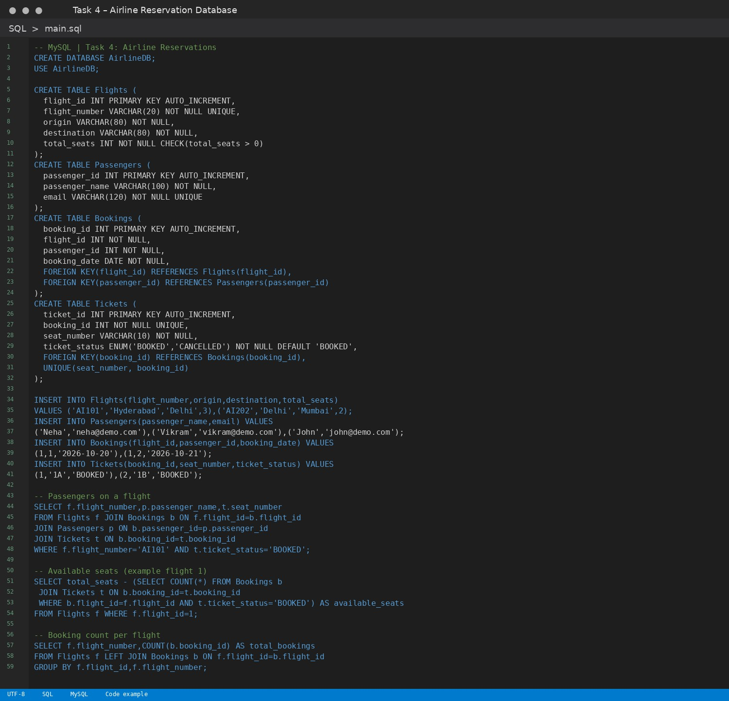

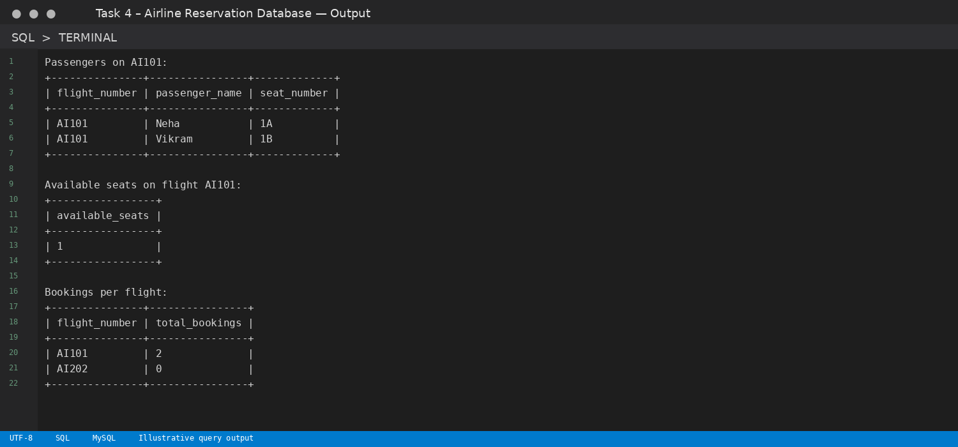
Note: For the airline task, available seats are calculated from booked tickets. For the hotel task, room availability uses overlapping date ranges, and occupancy is calculated for the selected date.

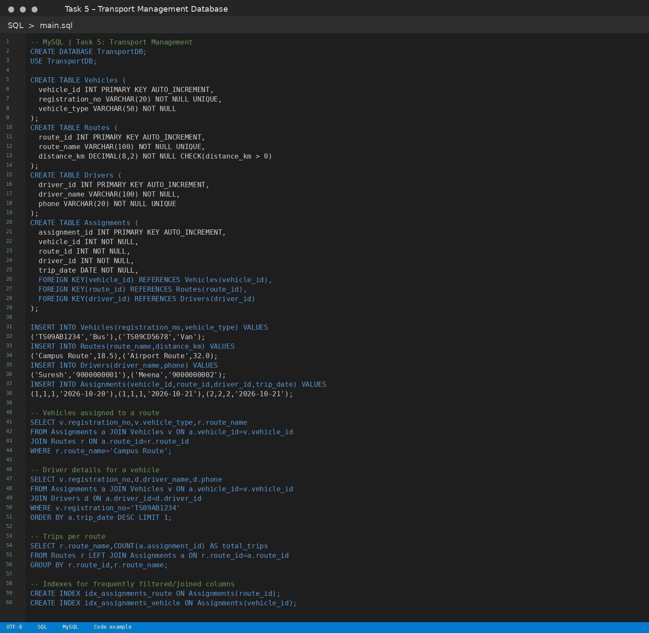

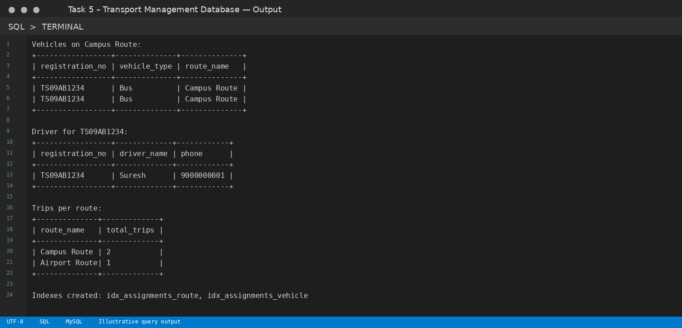
Note: For the airline task, available seats are calculated from booked tickets. For the hotel task, room availability uses overlapping date ranges, and occupancy is calculated for the selected date.

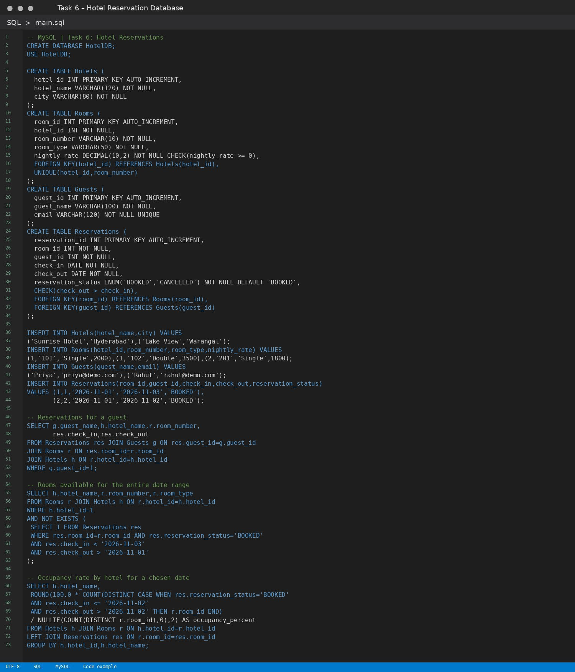

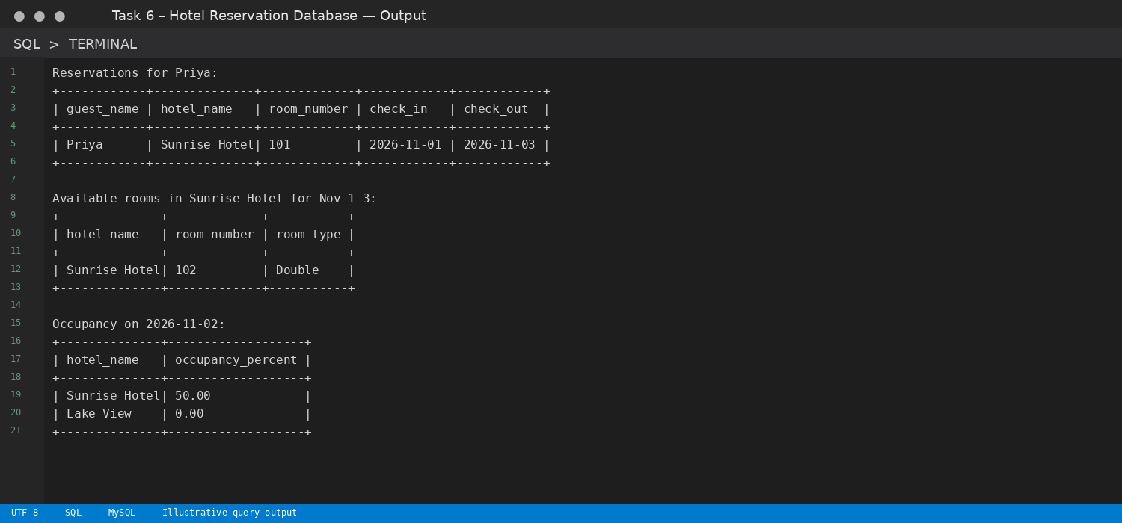
Note: For the airline task, available seats are calculated from booked tickets. For the hotel task, room availability uses overlapping date ranges, and occupancy is calculated for the selected date.

